# File permissions in Linux

## Project description

In this brief project, I will demonstrate my understanding and knowledge of displaying, navigating, and altering directory/file permissions using linux terminal commands.

## Check file and directory details

To check the permissions of files in a directory, you can use the ls command with the -la extension to display the permissions of all visible and hidden files.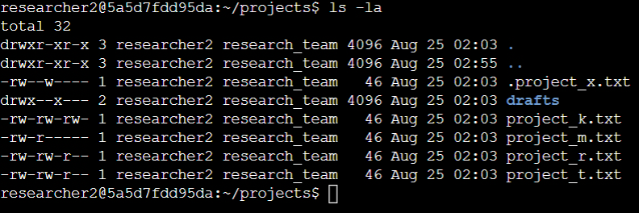

## Describe the permissions string

For the following description I will analyze the permissions of (.project_x.txt).

* The first letter in the string is ‘-‘ meaning that this is a file and not a directory (instead of ‘-‘ it would be ‘d’ if it was a directory).
* The following three letters are the permissions for one of the three user groups, this one being the local user. In this case, ‘r’, ‘w’, and ‘-’, or ‘rw-‘ represent the permissions, meaning that the user can read and write, but not execute. If the user had no permissions, it would be ‘---’ or, if the user could only read the permissions would be ‘r—‘. In cases of files, reading means opening the file and being able to see its contents, writing means altering and modifying the file, and execute means running/executing the file.
* The next three letters represent the group permissions, which in this case is ‘-w-‘, meaning that the group can only write to the file, but not read or execute it. This means that anyone in the specified group can contribute to a file, but they cannot read back their contributions.
* The following three letters is ‘---” represent the ‘Other’ group permissions, which in this case means that the ‘Other’ group has zero access to this file. This is likely due to the concept of least access – to ensure people have the minimal access to only files that are relevant to them.

## Change file permissions

To change the permissions I will use the chmod command. After ‘chmod’ I will first declaire what group I will be altering – in this case I will be altering permissions for ‘Other’ or ‘o’. I want to get rid of the write permissions so I will write a minus sign and w (for ‘write’) next to ‘o’, to indicate I want to remove ‘write’ permissions. Then I will specify the relevant file in the directory that I want this change to be made on.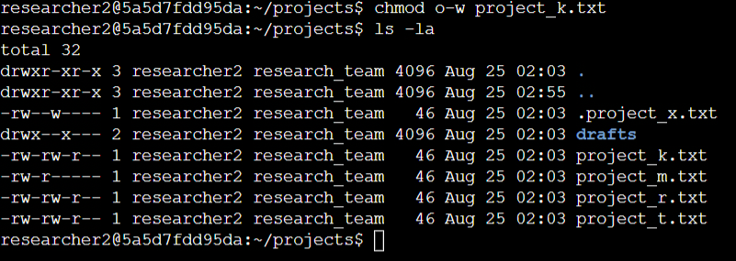

## Change file permissions on a hidden file

I will be using the chmod command again, except this time, I will be adding extra parameters to change multiple groups and permissions at once. It’s the same structure as before, except I chain the multiple changes with a comma.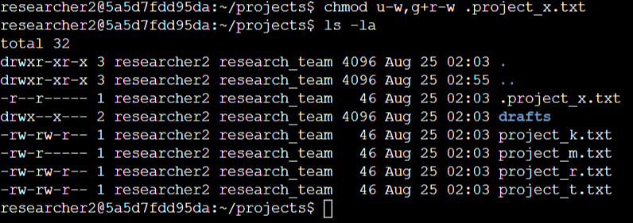

## Change directory permissions

I will use the chmod command again, and remove the existing permissions from all groups except user.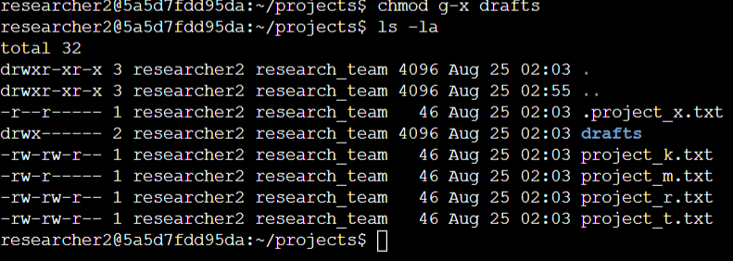

## Summary

In summary, altering linux file and directory permissions can be done in many ways, one of the easiest being the chmod command. Different files require different permissions, and it’s important for an organizations security posture to ensure proper access levels to their data to ensure only the right people have access and to minimize attack surface area.